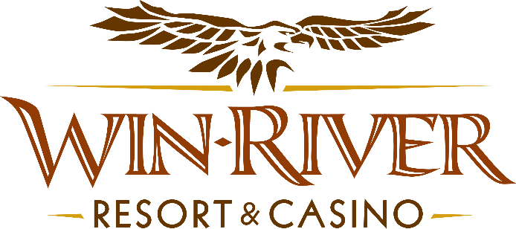

2024 Table Games Hot Seat Haven
Official Rules

- This promotion will run Friday, March 1st, 15th, and 29th, from 7 PM to 9 PM

- 2 winners every half-hour for our Hot Seat prize of $100 in chips or a $50 Dining Voucher. The last winner of the night will have a chance to win $200 in chips

- To participate in this promotion, guests must check in at the 21 Pit with their River Club Card.
- All 21 Pit tables are eligible.
- All winners must sign a winner’s log.
- Must have River Club Card and Valid ID.
  - A Valid ID includes the following: Guest Photo, Guest Name, Expiration Date, Issuing Government & Address. If the ID does not have an expiration date it is only valid up to 8 years after the issue date with the exception of Military ID.
  - If the guest does not have a Valid ID, then the prize will be forfeited.

- 9 Winners Total
PRIZES:

- 7pm | 2 Winners Drawn for $50 Dining Voucher or $100 in Chips
- 7:30pm | 2 Winners Drawn for $50 Dining Voucher or $100 in Chips

- 8pm | 2 Winners Drawn for $50 Dining Voucher or $100 in Chips
- 8:30pm | 2 Winners Drawn for $50 Dining Voucher or $100 in Chips

- 9pm | 1 Winner Drawn for $200 Chips

- The person whose name is drawn first will be awarded $100 worth of chips.

- Win-River Resort & Casino team members are not eligible to participate in this promotion. The Marketing divisions immediate family members are not eligible to participate in this promotion.
  - Spouse, domestic partner, parents, step-parents, siblings, step-siblings, children, step-children, grandparents, and grandchildren. This definition includes a team member’s eligible family member whether related by blood or adoption
- Win-River Resort & Casino reserves the right to change, modify or cancel this promotion at any time without prior notice.
- In accordance with the Internal Revenue Services, winners of prizes valued at $600 or above must provide their name, address and tax payer identification number (SSN) prior to receiving their prize. A 1099 Tax Form will be submitted

Rules are subject to change. Must be a River Club Member to participate and have a valid ID. Must be 21 years or older to participate in any aspect of this promotion. Win-River Resort & Casino reserves the right to change or cancel this promotion at any time without prior notice.

