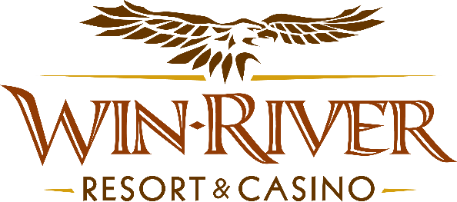

2024 Slot’s Blossoming Fortunes Drawing

Official Rules

- This promotion will take place Tuesdays in April from 6 pm – 8 pm on the casino floor.

Drawing Dates:
April 2, 9, 16, 23 & 30

Two (2) hot seat winners will be drawn every 30 minutes to participate in the drawing to win Free Slot Play or Cash
- Each winner will pick a flower pot to win Cash or Free Slot Play
    - In the event of an error, (example: If the puck gets stuck in the middle of the board or does not land in a specific winning section), a Promotions Team Member will VOID the drop, and let the contestant re-drop the puck.

Prize Amounts:
- $200 Cash
- $100 Cash
- $150 Free Slot Play

- NO DUPLICATE WINNERS.
- Guests must be playing with a matching River Club Card & have a Valid ID to participate.
  - A Valid ID includes the following: Guest Photo, Guest Name, Expiration Date, an Issuing Government & Address. If the ID does not have an expiration date it is only valid up to 8 years after the issue date with the exception of Military ID.
  - If the guest does not have a Valid ID, then the prize will be forfeited and the Promotions Team Member will draw for a new winner.
- Winners must sign the winner’s log.
- All Cash payouts will be done at the River Club.
- Free Slot Play can only be redeemed on Slot Machines and is non-transferable.
- All Free Slot Play expires one week from the date & time issued
- See River Club for instructions on using Free Slot Play on slot machines.
- Win-River Resort & Casino team members are not eligible to participate in this promotion. The Marketing division's immediate family members are not eligible to participate in this promotion.
- As defined in the WRRC Team Member Handbook Section 6.4 “immediate family member” includes the following:
  - Spouse, domestic partner, parents, step-parents, siblings, step-siblings, children, step-children, grandparents, and grandchildren. This definition includes a team member’s eligible family member whether related by blood or adoption.
- Win-River Resort & Casino and our designee(s) may use names and likenesses of Promotion winner(s) for promotional purposes without further compensation to Win-River Resort & Casino or the Promotion winner(s).
- In accordance with the Internal Revenue Services, winners of prizes valued at $600 or above must provide their name, address and tax payer identification number (SSN) prior to receiving their prize. A 1099 Tax Form will be submitted.
Rules are subject to change. Must have a River Club Card and valid ID. Must be 21 years or older to participate in any aspect of this promotion. Win-River Resort & Casino reserves the right to change, modify or cancel this promotion at any time without prior notice.

