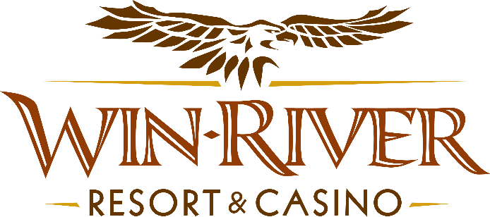

2024 Table Games Sunset Hot Seats
Official Rules

- This promotion will run Friday, June 14, 28, & July 12, 26; 3PM – 6PM in the 21 Pit

- 2 Hot Seat Winners will be drawn every half hour to win Chips or Free Sot Play, or $50 Dining Voucher.
Prizes:
- 3 pm | 2 winners drawn for a $50 Dining Voucher
- 3:30 pm | 2 winners drawn for $75 FSP
- 4 pm | 2 Winners drawn for $50 Dining Voucher
- 4:30 pm | 2 winners drawn for $100 Chips
- 5 pm | 2 winners drawn for 150 FSP
- 5:30 pm | 2 winners drawn for $150 Chips
- 6 pm | 2 winners for $200 Chips

- To participate in this promotion, guests must check in at the 21 Pit with their River Club Card.
- All 21 Pit tables are eligible.
- Must have a matching River Club Card and Valid ID to participate. .
  - A Valid ID includes the following: Guest Photo, Guest Name, Expiration Date, Issuing Government and address. If the ID does not have an expiration date it is only valid up to 8 years after the issue date with the exception of Military ID.
  - If the guest does not have a Valid ID, then the prize will be forfeited.
- All winners must sign the winner’s log.
- No duplicate winners within the same half hour.
- Any free slot play amount won that is over $100 will expire one (1) week from the date issued.
- Free Slot Play is only acceptable for slot machines.
- Free Slot Play is non-transferable and has no cash value.
- See River Club for instructions on using free play on slot machines.

- Win-River Resort & Casino team members are not eligible to participate in this promotion. The Marketing divisions immediate family members are not eligible to participate in this promotion.
  - Spouse, domestic partner, parents, step-parents, siblings, step-siblings, children, step-children, grandparents, and grandchildren. This definition includes a team member’s eligible family member whether related by blood or adoption
- Win-River Resort & Casino reserves the right to change, modify or cancel this promotion at any time without prior notice.
- In accordance with the Internal Revenue Services, winners of prizes valued at $600 or above must provide their name, address and tax payer identification number (SSN) prior to receiving their prize. A 1099 Tax Form will be submitted

Rules are subject to change. Must be a River Club Member to participate and have a valid ID. Must be 21 years or older to participate in any aspect of this promotion. Win-River Resort & Casino reserves the right to change or cancel this promotion at any time without prior notice.

