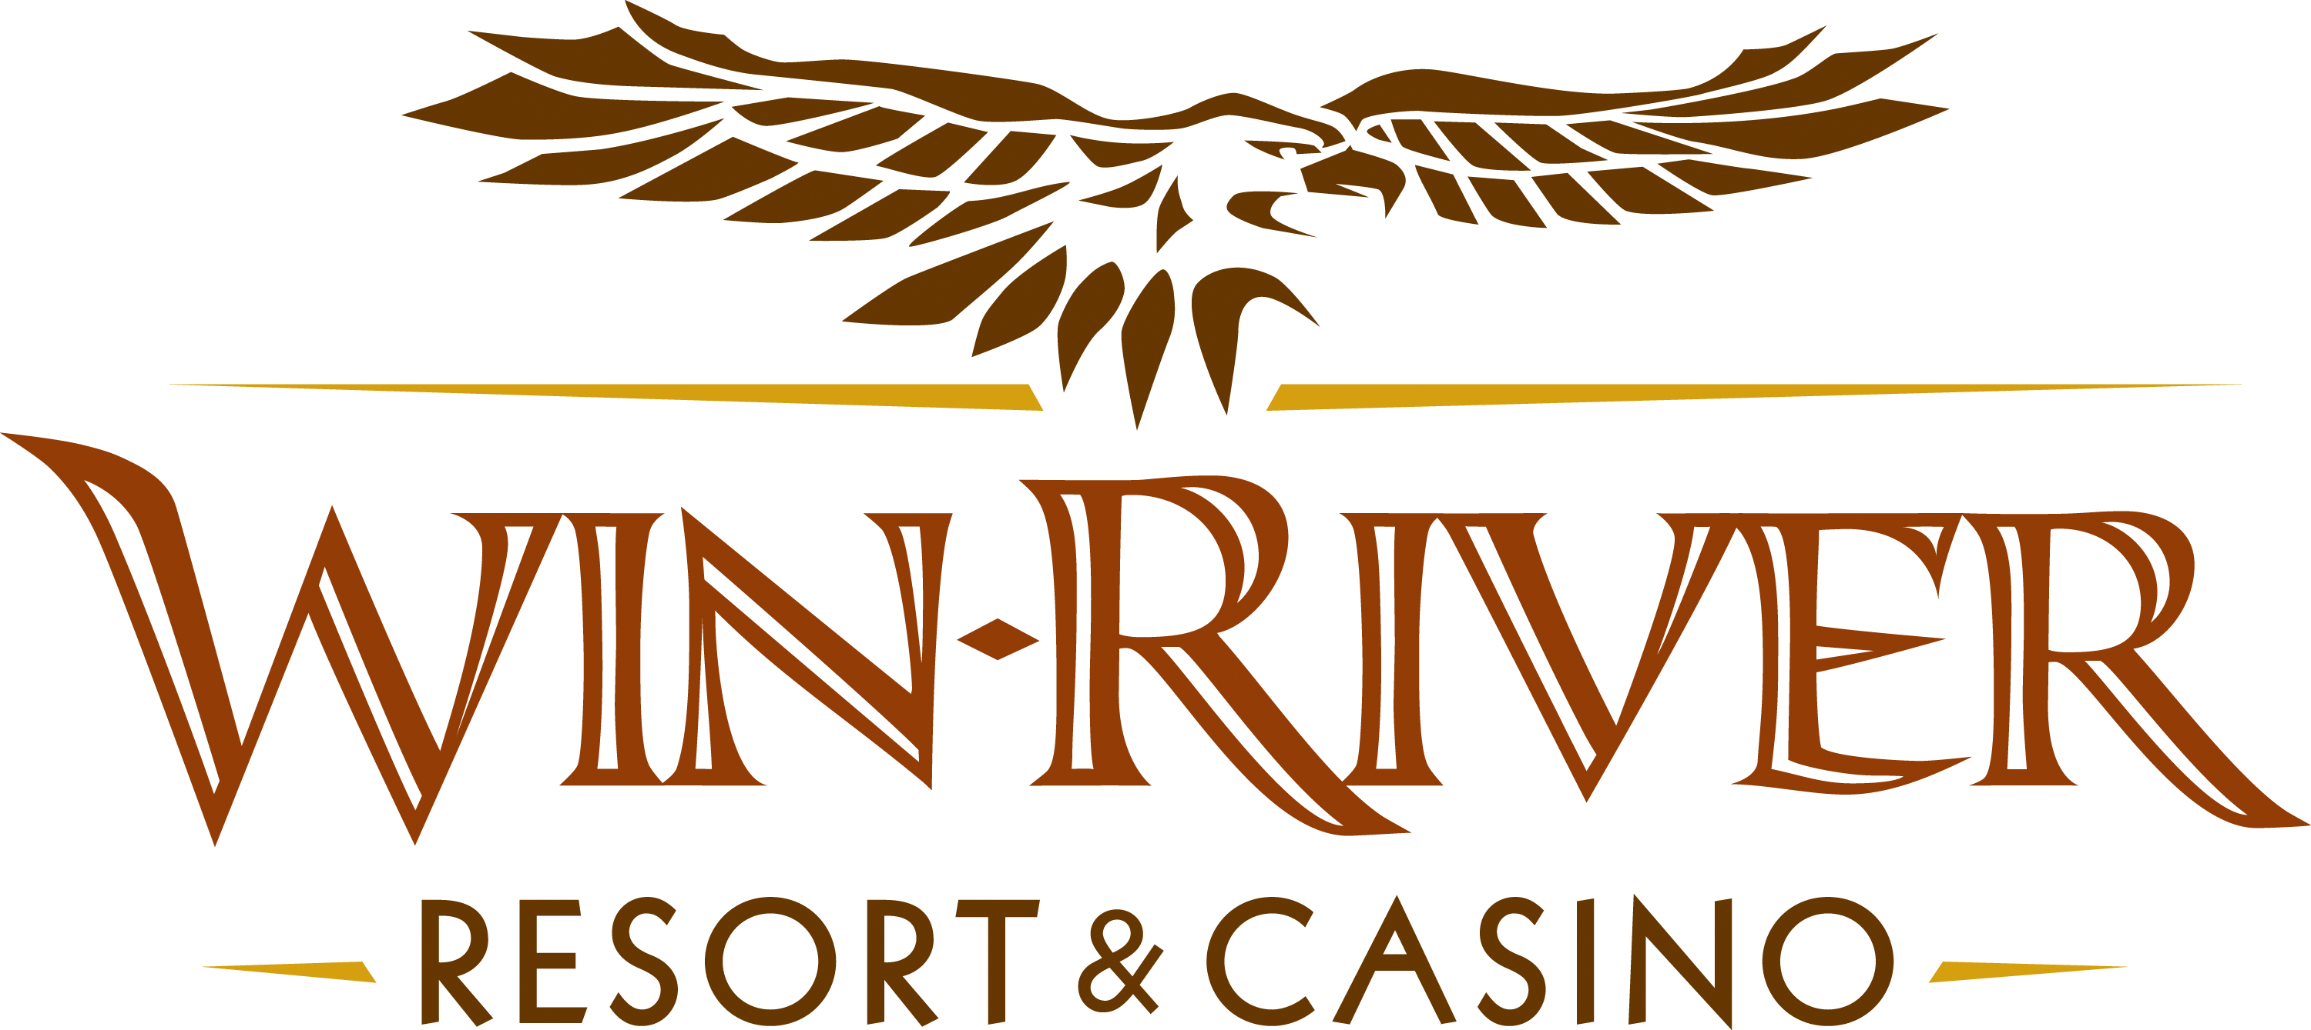

2024 $50,000 Cash Harvest S2W Drawing
Official Rules
September 1 – October 31

Weekly Drawings Thursdays from 7pm – 9pm on the Casino floor
September 5, 12, 19
October 3, 10, 17, 24
7pm:
- 5 winners are virtually drawn to win $50 Free Slot Play
7:30pm:
- 5 winners are virtually drawn to win $100 Free Slot Play
8pm:
- 5 winners are virtually drawn to win $150 Free Slot Play
8:30pm:
- 5 winners are virtually drawn to win $175 Free Slot Play
9pm:
- 5 winners are virtually drawn to win $200 Free Slot Play

Final drawings Thursday, September 26 & October 31 7pm – 9pm
7pm:
- 5 winners are virtually drawn to win $200 Cash
- 1 winner is virtually drawn to win $2,000 Cash
7:30pm:
- 5 winners are virtually drawn to win $200 Cash
- 1 winner is virtually drawn to win $2,000 Cash
8pm:
- 5 winners are virtually drawn to win $200 Cash
- 1 winner is virtually drawn to win $2,000 Cash
8:30pm:
- 5 winners are virtually drawn to win $200 Cash
- 1 winner is virtually drawn to win $2,000 Cash
9pm:
- 5 winners are virtually drawn to win $200 Cash
- 1 winner is virtually drawn to win $2,000 Cash

Weekly Drawings
- A Promotions Team Member will call names over PA/intercom.
- Guests can have their names called twice during weekly drawings.
- Guests have five (5) minutes to claim their prize; if not claimed within five (5) minutes, a Promotions Team Member will draw another name until all five (5) prizes have been claimed.
- Winners must have a matching Valid ID and River Club Card to participate and claim a prize.
  - A Valid ID includes the following: Guest Photo, Guest Name, Expiration Date, Issuing Government & Address. If the ID does not have an expiration date it is only valid up to 8 years after the issue date with the exception of Military ID.
  - If the guest does not have a valid ID, then the prize will be forfeited and the Promotions Team Member will draw for a new winner.
- Winners must sign the winner’s log.
- All cash payouts will be made at the River Club, following the completion of the drawing.
- Winners are responsible for all taxes, licenses, and fees.
- Foreign winners must pay taxes upon winning otherwise their prize is forfeited and a new winner will be chosen.
Entries
- Win-River Resort & Casino carded guests may swipe their free River Club Card daily at any of the Promotional Kiosks located throughout the gaming floor. Instant Prizes will vary.
- Any carded guest that earns 200 points in a 24-hour promotional period will receive an extra entry into that weekly drawing.
- Earn 200 points and receive 4X’s entries on Sundays & Mondays
- Check-in and activate entries by: Checking in at any Promotional Kiosk or by visiting the Promotions Stage.
- Guests can check-in between 6pm and 9pm on drawing nights
  - Once checked into the drawing, guest will be checked into all S2W drawings for that night.
  - Guests cannot activate their entries while a drawing is active and names are being called
- All entries earned from September 1 – September 26 will be included in the September final drawing.
- All entries earned from September 1 – October 31 will be included in the October final drawing.

Instant Prizes
- All Free Slot Play will expire at 11:50pm on the day it is issued. All other prizes expire 24 hours from issue date.
  - $5 Off $20 Dining * All Dining coupons can be redeemed at Seasons and expire 24-hours from date and time ticket is printed. (excludes Alcohol and gratuity)
  - $5 Off $20 Gift Shop Purchase * All coupons can be redeemed at Gift Shop and expire 24-hours from date and time ticket is printed. (excludes Tobacco, Alcohol and gratuity)
  - Must show River Club Card or valid I.D at Seasons, Gift Shop, & River Club. Coupon can only be used by person named on receipt.
Earning Period will be as follows:
- September 1 – October 31
- Guests have 5 minutes to claim prize.
- All Winners must have a River Club Card and Valid ID to claim prize.
- If a guest cannot present a valid ID in the 5 minutes, guest will forfeit prize.
- Winners must sign winner’s log.
- Winner is responsible for all taxes, licenses, and fees.
- Practice social distancing guidelines and do not gather in large groups.
  - Safety protocols must be followed.
- Win-River Resort & Casino team members are not eligible to participate in this promotion. The Marketing team member’s immediate family members are not eligible to participate in this promotion.
- As defined in the WRRC Team Member Handbook Section 6.4 “immediate family member” includes the following:
  - Spouse, domestic partner, parents, stepparents, siblings, stepsiblings, children, stepchildren, grandparents, and grandchildren. This definition includes a team member’s eligible family member whether related by blood or adoption
- Accounting is responsible for auditing, verifying and recording both the revenue and expense side of the transaction.
- Win-River Resort & Casino and our designee(s) may use names and likenesses of Promotion winner(s) for promotional purposes without further compensation to Win-River Resort & Casino or the Promotion winner(s).
- In accordance with the Internal Revenue Services, winners of prizes valued at $600 or above must provide their name, address and tax payer identification number (SSN) prior to receiving their prize. A 1099 Tax Form will be submitted.
- Winner must sign a Prize Voucher form, and winner’s log.
  - If winner does not have a social security card with them, a W-9 must be filled out and signed.

Rules are subject to change. Must have a valid ID. Must be 21 years or older to participate in any aspect of this promotion. Win-River Resort & Casino reserves the right to change or cancel this promotion at any time without prior notice.

