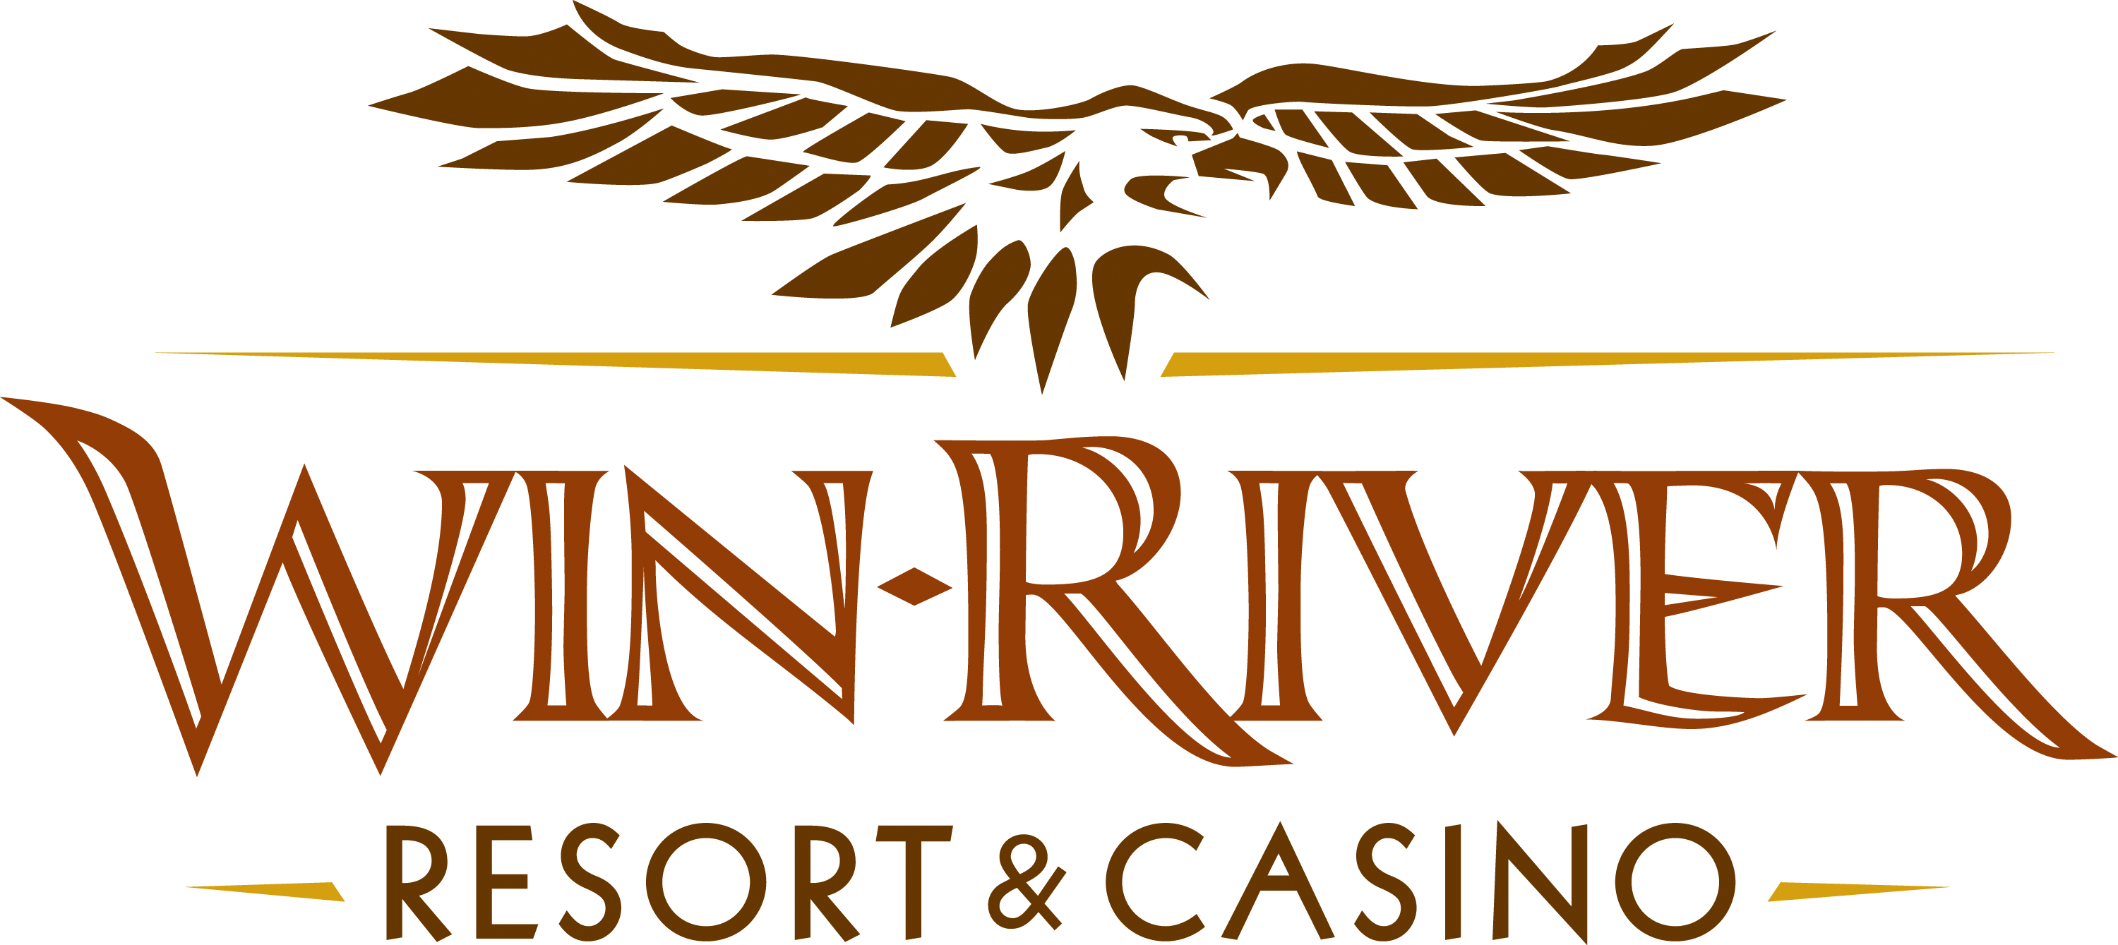

2024 Monday Night Football
Official Rules
Revised 9.23.24

- This promotion will run every Monday from September 9, 2024 through December 30, 2024.
- This promotion will be held in the Overtime from 4pm until the end of game.

Every Monday Night either a pair of 49er Home Game Tickets marked in Green or a Watch Party Package marked in Blue will be given away.
Monday Night Football Schedule
Week 1 – September 9 | NY Jets @ San Francisco 49ers
Week 2 – September 16 | Atlanta Falcons @ Philadelphia Eagles
Week 3 – September 23 | Washington Commanders @ Cincinnati Bengals
Week 4 – September 30 | Seattle Seahawks @ Detroit Lions
Week 5 – October 7 | New Orleans Saints @ Kansas City Chiefs
Week 6 – October 14 | Buffalo Bills @ New York Jets
Week 7 – October 21 | Baltimore Ravens @ Tampa Bay Buccaneers
Week 8 – October 28 | New York Giants @ Pittsburgh Steelers
Week 9 – November 4 | Tampa Bay Buccaneers @ Kansas City Chiefs
Week 10 – November 11 | Miami Dolphins @ Los Angeles Rams
Week 11 – November 18 | Houston Texans @ Dallas Cowboys
Week 12 – November 25 | Baltimore Ravens @ Los Angeles Chargers
Week 13 – December 2 | Cleveland Browns @ Denver Broncos
Week 14 – December 9 | Cincinnati Bengals @ Dallas Cowboys
Week 15 – December 16 | Atlanta Falcons @ Las Vegas Raiders
Week 16 – December 23 | New Orleans Saints @ Green Bay Packers
Week 17 – December 30 | Detroit Lions @ San Francisco 49ers
Checking in:
- Guests will come up to the Promotions Table with their River Club Card to check in.
- A Promotions Team Member will fill out 2 Standard Drawing Tickets.
- Every guest that checks in will receive one RED raffle ticket.
  - RED raffle tickets are used for Prize Drawings
- When a guest is checking-in, they will have a chance to play Plinko to earn 2, 3, 4 or 5 extra RED raffle tickets.
  - In the event of an error, (example: If the puck gets stuck in the middle of the board or does not land in a specific winning section), the Promotions Team Member will VOID the drop, and let the contestant re-drop the puck.
- Guests can receive RED raffle tickets by:
  - Checking in with their River Club Card – One Ticket
  - Wearing a Win-River Monday Night Football Shirt or NFL Apparel ( hat, shirt, shoes, socks, etc.) - 5 ticket limit on attire
  - Play Mini Plinko Game. – Up to 5 Tickets
  - Purchasing food from the Stadium Snack Menu. – One ticket per Food Item
  - Checking in to Win-River Resort & Casino on Social Media – One Ticket

MNF Team Drawing:
  - Guests place the Generic Drawing Ticket they received at check in into the teams drawing drum they think will win.
  - Guests must place ticket in a drawing drum before the first team scores.
  - Five (5) winners will be drawn out of the winning team drawing drum after the game has ended.
    - Winners will receive $100 cash.
  - In the result of a tie, all tickets will be put into one drum.
49er tickets or BBQ Package Giveaway:
  - At the 2-minute warning of the game, a promotions Team Member will draw a ticket for either a pair of 49er home game tickets, or a Watch Party Package
Watch Party Package
- Mini Projector - $69.49
- 100in Projector Screen - $53.99
- Football Serving Trays – $42.93
    - Total Value: $166.41
  - Winner must be present to win.
  - Winner has one minute to claim prize.
Drawing for Ultimate Tailgate Party
Monday, December 30, 2024 after game.
- Winner will be drawn from check-in standard drawing tickets.
- One (1) name will be drawn to win a table of ten (10) to the 2025 Ultimate Tailgate Party on Sunday, February 9, 2025 in the Event Center.
  - Guests have 1 minute to claim prize.
  - If a drawing ticket is not legible, tampered with in any way or a duplicate winner, Team Member will re-draw a new ticket.
  - Must have a River Club Card and have a matching valid ID to participate.
    - A Valid ID includes the following: Guest Photo, Guest Name, Expiration Date, Issuing Government & Address. If the ID does not have an expiration date it is only valid up to 8 years after the issue date with the exception of Military ID.
    - If the guest does not have a Valid ID, then the prize will be forfeited.
- Promotions Team Member will draw another name until claimed.
- Winners must have a matching Valid ID and River Club Card to participate in any aspect of this promotion.
- Winner’s must sign all winner’s logs.
- Win-River Resort & Casino team members are not eligible to participate in this promotion. The Marketing team member’s immediate family members cannot participate in any drawing associated to a promotion.
  - Spouse, domestic partner, parents, step-parents, siblings, step-siblings, children, step-children, grandparents, and grandchildren. This definition includes a team member’s eligible family member whether related by blood or adoption
- Win-River Resort & Casino and our designee(s) may use names and likenesses of Promotion winner(s) for promotional purposes without further compensation to Win-River Resort & Casino or the Promotion winner(s).
- Win-River Resort & Casino reserves the right to change, modify or cancel this promotion at any time without prior notice.
- In accordance with the Internal Revenue Services, winners of prizes valued at $600 or above must provide their name, address and tax payer identification number (SSN) prior to receiving their prize. A 1099 Tax Form will be submitted.

Rules are subject to change. Must be a River Club Member to participate and have a valid ID. Must be 21 years or older to participate in any aspect of this promotion. Win-River Resort & Casino reserves the right to change or cancel this promotion at any time without prior notice.

