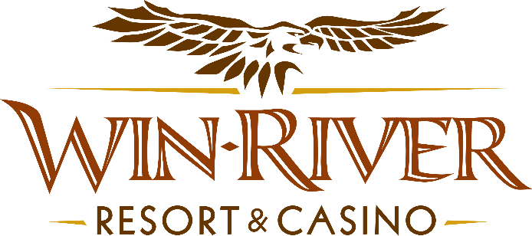

**2024 Poker Room Play to Win**

**Official Rules**

**Revised 9.4.24**

* This promotion will run Friday, November 1 & 29, and December 13 & 27, from 4pm to 7pm, in the Poker Room.
* ***At 4pm, 5pm & 6pm, one lucky Hot Seat Winner will be drawn to receive $100 in chips***
* ***At 4:30pm, 5:30pm & 6:30pm, 2 Hot Seat Winners will be drawn to win $100 Free Sot Play.***
* ***At 7pm, 1 hot seat winner is drawn to receive $100 Chips & one winner is drawn to win $175 Chips***

***Prizes:***

* **$100 Chips – 4 winners**
* **$100 in Free Slot Play – 6 winners**
* **$175 Chips – 1 winner**
* To participate in this promotion, guests must check in at the Poker Room with their River Club Card.
* All live Poker Room Tables are eligible.
* Must have a matching River Club Card and Valid ID to participate. .
  + A Valid ID includes the following: Guest Photo, Guest Name, Expiration Date, Issuing Government and address. If the ID does not have an expiration date it is only valid up to 8 years after the issue date with the exception of Military ID.
  + If the guest does not have a Valid ID, then the prize will be forfeited.
* ***All winners must sign the winner’s log.***
* **No duplicate winners within the same half hour.**
* All free slot play won will expire one (1) week from the date issued.
* Free Slot Play is only acceptable for slot machines.
* Free Slot Play is non-transferable and has no cash value.
* See River Club for instructions on using free play on slot machines.
* Win-River Resort & Casino team members are not eligible to participate in this promotion. The Marketing divisions immediate family members are not eligible to participate in this promotion.
  + Spouse, domestic partner, parents, step-parents, siblings, step-siblings, children, step-children, grandparents, and grandchildren. This definition includes a team member’s eligible family member whether related by blood or adoption
* Win-River Resort & Casino reserves the right to change, modify or cancel this promotion at any time without prior notice.
* In accordance with the Internal Revenue Services, winners of prizes valued at $600 or above must provide their name, address and tax payer identification number (SSN) prior to receiving their prize. A 1099 Tax Form will be submitted

*Rules are subject to change. Must be a River Club Member to participate and have a valid ID. Must be 21 years or older to participate in any aspect of this promotion. Win-River Resort & Casino reserves the right to change or cancel this promotion at any time without prior notice.*