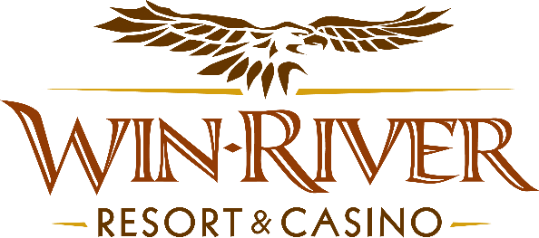

# **2024 Slot’s Pumpkin Patch Payouts Drawing**

# **Official Rules**

* This promotion will take place Tuesdays in November from 6pm – 8pm on the casino floor.

**Drawing Dates:**

**November 5, 12, 19 & 26**

# One (1) hot seat winner will be drawn every 15 minutes to participate in the drawing to win Free Slot Play or Cash

* Each winner toss a Bean Bag through one of the holes in the Game Board to win Free Slot Play or Cash.
  + - In the event of an error, (example: If the Bean Bag gets thrown over the game board.), a Promotions Team Member will VOID the throw, and let the contestant re-throw the Bean Bag.

**Prize Amounts:**

* **$50 Cash**
* **$75 Cash**
* **$50 Free Slot Play**
* **$100 Cash (on the hour of 7pm and 8pm)**
* **NO DUPLICATE WINNERS.**
* Guests must be playing with a River Club Card & have a matching Valid ID to participate.
  + A Valid ID includes the following: Guest Photo, Guest Name, Expiration Date, an Issuing Government & Address. If the ID does not have an expiration date it is only valid up to 8 years after the issue date except for Military ID.
  + If the guest does not have a Valid ID, the prize will be forfeited and the Promotions Team Member will draw for a new winner.
* Winners must sign the winner’s log.
* **All Cash payouts will be done at the River Club.**
* Free Slot Play can only be redeemed on Slot Machines and is non-transferable.
* All Free Slot Play expires within 24 hours of the time issued.
* See River Club for instructions on how to use Free Slot Play on slot machines.
* Win-River Resort & Casino team members are not eligible to participate in this promotion. The Marketing division's immediate family members are not eligible to participate in this promotion.
* As defined in the WRRC Team Member Handbook Section 6.4 “immediate family member” includes the following:
  + Spouse, domestic partner, parents, step-parents, siblings, step-siblings, children, step-children, grandparents, and grandchildren. This definition includes a team member’s eligible family member whether related by blood or adoption.
* Win-River Resort & Casino and our designee(s) may use the names and likenesses of the Promotion winner(s) for promotional purposes without further compensation to Win-River Resort & Casino or the Promotion winner(s).
* By the Internal Revenue Service, winners of prizes valued at $600 or above must provide their name, address, and taxpayer identification number (SSN) before receiving their prize. A 1099 Tax Form will be submitted.

*Rules are subject to change. Must have a River Club Card and a valid ID. You must be 21 years or older to participate in this promotion. Win-River Resort & Casino reserves the right to change, modify, or cancel this promotion at any time without prior notice.*