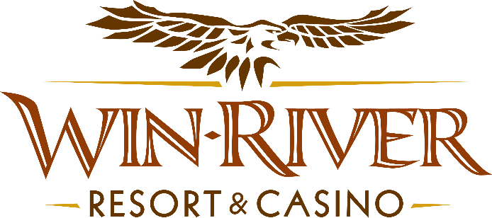

**2024 Table Games Blackjack Bonanza**

**Official Rules**

* This promotion will run Friday October 4th, 18th & Friday November 8th, 22nd from 4pm – 6pm
* Top 10 winners with the most blackjacks will receive the following:
* 1st - $450 Chips
* 2nd - $350 Chips
* 3rd - $250 Chips
* 4th - $150 Chips
* 5th – 10th - $100 Free Slot Play.
* To participate in this promotion, guests must check in at any blackjack table with their River Club Card.
* The Promotions Team Member will keep track of players' Blackjacks and write the top 10 on a whiteboard posted in the 21 Pit.
* All Blackjack tables are eligible.
* All winners must sign a winner’s log.
* Must have a matching River Club Card and Valid ID to participate.
  + A Valid ID includes the following: Guest Photo, Guest Name, Expiration Date, Issuing Government, and address. If the ID does not have an expiration date it is only valid up to 8 years after the issue date with the exception of Military ID.
  + If the guest does not have a Valid ID, then the prize will be forfeited.
* Any free slot play amount won that is over $100 will expire one (1) week from the date issued.
* Free Slot Play is only acceptable for slot machines.
* Free Slot Play is non-transferable and has no cash value.
* See River Club for instructions on using free play on slot machines.
* Win-River Resort & Casino team members are not eligible to participate in this promotion. The Marketing division's immediate family members are not eligible for this promotion.
  + Spouse, domestic partner, parents, step-parents, siblings, step-siblings, children, step-children, grandparents, and grandchildren. This definition includes a team member’s eligible family member whether related by blood or adoption
* Win-River Resort & Casino reserves the right to change, modify, or cancel this promotion at any time without prior notice.
* In accordance with the Internal Revenue Service, winners of prizes valued at $600 or above must provide their name, address, and taxpayer identification number (SSN) prior to receiving their prize. A 1099 Tax Form will be submitted

*Rules are subject to change. Must be a River Club Member to participate and have a valid ID. Must be 21 years or older to participate in any aspect of this promotion. Win-River Resort & Casino reserves the right to change or cancel this promotion at any time without prior notice.*