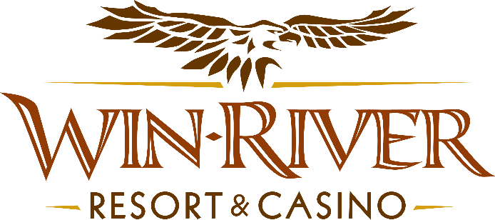

**2024 Deck the Halls with Table Games Rules**

* This promotion will run Monday, December 2nd, & 16th, from 7pm - 9pm.
* ***Guests must be checked in at any table with a River Club Card & matching valid ID to participate***
* Two winners every half hour (10 winners total) will be drawn to choose a gift box containing a prize of Chips, or Free Slot Play

***Prize Amounts:***

* + ***$100 Free Slot Play***
  + ***$150 Free Slot Play***
  + ***$100 Chips***
  + ***$150 Chips***
  + ***$200 Chips***
* To participate in this promotion, guests must check in at the 21 Pit with their River Club Card.
* Must have a matching River Club Card and Valid ID to participate. .
  + A Valid ID includes the following: Guest Photo, Guest Name, Expiration Date, Issuing Government and address. If the ID does not have an expiration date it is only valid up to 8 years after the issue date with the exception of Military ID.
  + If the guest does not have a Valid ID, then the prize will be forfeited.
* ***All winners must sign the winner’s log.***
* **No duplicate winners within the same half hour.**
* Any free slot play amount won that is over $100 will expire one (1) week from the date issued.
* Free Slot Play is only acceptable for slot machines.
* Free Slot Play is non-transferable and has no cash value.
* See River Club for instructions on using free play on slot machines.
* Win-River Resort & Casino team members are not eligible to participate in this promotion. The Marketing divisions immediate family members are not eligible to participate in this promotion.
  + Spouse, domestic partner, parents, step-parents, siblings, step-siblings, children, step-children, grandparents, and grandchildren. This definition includes a team member’s eligible family member whether related by blood or adoption
* Win-River Resort & Casino reserves the right to change, modify or cancel this promotion at any time without prior notice.
* In accordance with the Internal Revenue Services, winners of prizes valued at $600 or above must provide their name, address and tax payer identification number (SSN) prior to receiving their prize. A 1099 Tax Form will be submitted

*Rules are subject to change. Must be a River Club Member to participate and have a valid ID. Must be 21 years or older to participate in any aspect of this promotion. Win-River Resort & Casino reserves the right to change or cancel this promotion at any time without prior notice.*