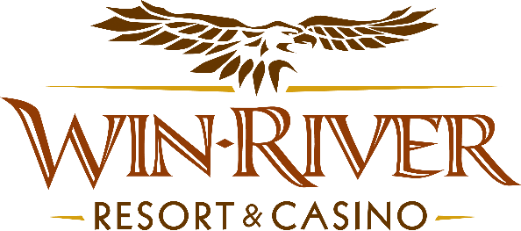

# **2025 Slot’s Ben’s Birthday Bucks**

* This promotion will occur on Friday, January 17th from 4PM - 8PM, on the casino floor.

# **Drawing Dates:**

**January 17**

This promotion will be held Friday, January 17th from 4PM - 8PM. 1 winner **(17 Winners in Total)** every 15 minutes will be randomly selected to win $100 Cash.

**Prizes**

**$100 Cash**

* **NO DUPLICATE WINNERS.**
* Guests must be playing with a matching River Club Card & have a Valid ID to participate.
  + A Valid ID includes the following: Guest Photo, Guest Name, Expiration Date, Issuing Government & Address. If the ID does not have an expiration date it is only valid up to 8 years after the issue date except Military ID.
  + If the guest does not have a Valid ID, the prize will be forfeited and the Promotions Team Member will draw for a new winner.
* Winners must sign the winner’s log.
* **All Cash Payouts will be paid at the River Club**
* Win-River Resort & Casino team members are not eligible to participate in this promotion. The Marketing division's immediate family members are not eligible to participate in this promotion.
* As defined in the WRRC Team Member Handbook Section 6.4 “immediate family member” includes the following:
  + Spouse, domestic partner, parents, step-parents, siblings, step-siblings, children, step-children, grandparents, and grandchildren. This definition includes a team member’s eligible family member whether related by blood or adoption.
* Win-River Resort & Casino and our designee(s) may use the names and likenesses of the Promotion winner(s) for promotional purposes without further compensation to Win-River Resort & Casino or the Promotion winner(s).
* By the Internal Revenue Service, winners of prizes valued at $600 or above must provide their name, address, and taxpayer identification number (SSN) before receiving their prize. A 1099 Tax Form will be submitted.

*Rules are subject to change. Must have a River Club Card and a valid ID. You must be 21 years or older to participate in any aspect of this promotion. Win-River Resort & Casino reserves the right to change, modify, or cancel this promotion at any time without prior notice. 1-800-GAMBLER*