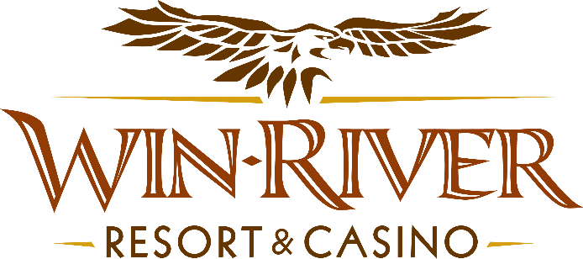

**2025 Lucky Giveaway in Table Games**

**Official Rules**

* This Promotion will occur on Monday, March 17th, 2025, at 3pm, 5pm, and 7pm.
* One Winner at 3pm, 5pm, and 7pm will have a chance to win a Stainless Steel Patio Heater, Smoke-Less Grill & Griddle, or a Roomba.
* To participate in this promotion, guests must check in at the 21 Pit with their River Club Card and have a matching valid ID.
* **All 21 Pit tables are eligible.**
* **No duplicate winners in the same hour.**
* All winners must sign a winner’s log.
* Must have a matching River Club Card and Valid ID.
  + A Valid ID includes the following: Guest Photo, Guest Name, Expiration Date, Issuing Government & Address. If the ID does not have an expiration date it is only valid up to 8 years after the issue date except Military ID.
  + If the guest does not have a Valid ID, then the prize will be forfeited.

**Promotional Pepsi Products**

**Prize Breakdown:**

**Patio Heater** - $199.99

**Smoke-Less Grill & Griddle** - $239.99

**Roomba** - $349.99

**Total: $789.97**

***3 PM: Stainless Steel Patio Heater***

***5 PM: Roomba***

***7 PM: Smoke-Less Grill & Griddle***

* The Promotions Team Member will log all winners on the winner log, with the amount won or what prize was chosen, and have the guest sign the winner’s log.
* Win-River Resort & Casino team members are not eligible to participate in this promotion. The Marketing division's immediate family members are not eligible to participate in this promotion.
  + Spouse, domestic partner, parents, step-parents, siblings, step-siblings, children, step-children, grandparents, and grandchildren. This definition includes a team member’s eligible family member whether related by blood or adoption
* Win-River Resort & Casino reserves the right to change, modify or cancel this promotion at any time without prior notice.
* In the event of a computer malfunction contact the IT Department for technical support.
* Contact the Director of Marketing for cancellation and/ or postponement of promotion.
* ***Management has the right to change, cancel, or modify promotion at any time.***
  + **Note:** When applicable, the Promotions Team Member will complete a Title 31 Multiple Transaction Log (MTL) for any **cash** payout of $2500 or more, and a preliminary Currency Transaction Report by Casinos for any **cash** payout of more than $10,000 ($10,000.01, for example.) Turn in the MTL and CTR to the Regulatory Compliance Manager by the next morning.
    - **See SOP-PC80 – Title 31 Multiple Transaction Log and SOP-PC81 – Currency Transaction Report.)** *

**Finance Process:**

* Foreign winners who win **$600** or more must pay 30% in taxes upon winning (see SOP CD021) otherwise their prize is forfeited and a new winner will be chosen.
* Win-River Resort & Casino team members are not eligible to participate in this promotion. The Marketing team member’s immediate family members are not eligible to participate in this promotion.
* As defined in the WRRC Team Member Handbook Section 6.4 “immediate family member” includes the following.
* Spouse, domestic partner, parents, step-parents, siblings, step-siblings, children, step-children, grandparents, and grandchildren. This definition includes a team member’s eligible family member whether related by blood or adoption
* Finance Department is responsible for auditing, verifying and recording both the revenue and expense side of the transaction.
* The operation must establish, as approved by the TGRA, the threshold level at which a variance must be reviewed to determine the cause. Any such review must be documented.
* If a variance occurs, see SOP PE-6 Variances for Temporary Promotions

Rules can be downloaded by the Players Club and Promotions Team Members from P:\2025 Rules. Rules may also be found by clicking the Official Rules link on WRRC website. www.winrivercasino.com

*Rules are subject to change. Must be a River Club Member to participate and have a valid ID. Must be 21 years or older to participate in any aspect of this promotion. Win-River Resort & Casino reserves the right to change or cancel this promotion at any time without prior notice.*