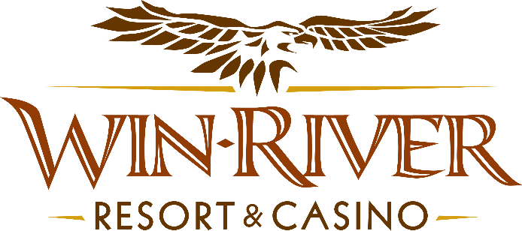

**2025 Series of Poker League**

**Official Rules**

* Guests can participate in Poker Tournaments every Thursday & Sunday in the Poker Room from **March 2, 2025**, through **May 29, 2025**.
* Top 10 point earners are rewarded at the end of each month.
* Top Overall Player receives $1,000 Cash & a spot on the Series of Poker League Champions Plaque.

**Poker Tournaments Promotion**

**$10 Series Fee**

**Thursday Tournament Buy-In:** **$85 Buy-In**

**$60 + $10 + $5**

**Sunday Tournament Buy-In:** **$95 Buy-In**

**$50 + $5 + $5**

**$25 Bounty Fee**

**Payout Dates:**

* ***March winners – April 3 to April 10***
* ***April winners – May 1 to May 8***
* ***May winners – June 5 to June 12***

**Earning points**

* Guests who participate in weekly poker tournaments will earn points based on their final position.
* Guests must have a River Club Card to participate in any tournament
  + There is a minimum of 20 participants needed for the tournament to qualify as a league tournament for guests to earn points.

**Finishing Positions & Points**

* 1 – 100
* 2 – 70
* 3 – 50
* 4 – 44
* 5 – 38
* 6 – 33
* 7 – 28
* 8 – 24
* 9 – 20
* 10 – 15
* Field size multipliers are applied based on the number of tournament participants.

**Field Size Multipliers**

* 20 – 25 | 1x
* 26 – 30 | 1.1x
* 31 – 35 | 1.15x
* 36 – 40 | 1.2x
* 41 + | 1.25x
* Example: If the tournament has 40 players, winners will receive a 1.2 multiplier – The player finishing in 5th place receives 38 x 1.2% = 45.6.

**Monthly Payouts**

* The top ten players will win cash every month based on their position.
* Winners will claim their prize in the Poker Room from a **Poker Team Member.**
  + Winners have one week from the payout date to claim their prize otherwise, their prize is forfeited.
* Cash winners will receive a **Gift Certificate** they can cash at the Cage.
  + **It is the winners’ responsibility to take their Gift Certificate to the Cage.**

**Monthly Winners Amounts**

* **1st – $599 Cash**
* **2nd – $400 Cash**
* **3rd – $300 Cash**
* **4th – $200 Cash**
* **5th-10th – $100 Cash**

**Tournament Champions**

* The player with the most points at the end of November will be the overall series champion and receive **$1,000 Cash** and have their name engraved on the series champion plaque.

***In the event that players unanimously decide to split the winnings instead of completing the tournament, all players must sign a winners log for the amount won.***

* Winners must have a matching River Club Card and Valid ID to claim their prize.
  + A Valid ID includes the following: Guest Photo, Guest Name, Expiration Date, Issuing Government & Address. If the ID does not have an expiration date it is only valid up to 8 years after the issue date with the exception of Military ID.
  + If the guest does not have a Valid ID, the prize will be forfeited.
* **Winners must sign the winner’s log before receiving their prize.**
* Win-River Resort & Casino team members and the immediate family members of the Marketing department are not eligible for promotions or giveaways.
* As defined in this WRRC Team Member Handbook Section 6.4 “immediate family member” includes the following.
  + Spouse, domestic partner, parents, stepparents, siblings, stepsiblings, children, stepchildren, grandparents, and grandchildren. This definition includes a team member’s eligible family member, whether related by blood or adoption.
* In accordance with the Internal Revenue Services, winners of prizes valued at $600 or above must provide their name, address and tax payer identification number (SSN) prior to receiving their prize. A 1099 Tax Form will be submitted.
* Win-River Resort & Casino and our designee(s) may use the names and likenesses of the Promotion winner(s) for promotional purposes without further compensation to Win-River Resort & Casino or the Promotion winner(s).

*Rules are subject to change. Must have a matching River Club Card and valid ID. Must be 21 years or older to participate in any aspect of this promotion. Win-River Resort & Casino reserves the right to change, modify or cancel this promotion at any time without prior notice.*