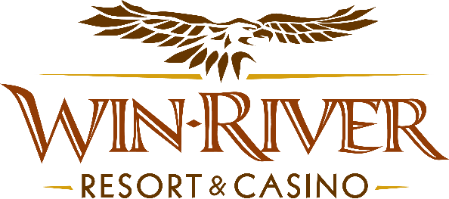

# **2025 Slot’s Lucky Love Birds**

# **Official Rules**

* This promotion will take place on Tuesdays in January from 6 pm to 8 pm on the casino floor.

# **Drawing Dates:**

**February 4, 18 & 25**

# Two (2) hot seat winners will be drawn every 30 minutes to participate in the drawing to win Free Slot Play or Cash

* Each winner will pick an envelope to win Cash or Free Slot Play.
  + - In the event of an error, (example: Someone spills a drink on it and it is no longer be legible.), a Promotions Team Member will VOID the choice and let them pick another envelope,

**Prize Amounts:**

**$150 Cash, $100 Cash**

**$75 Free Slot Play, $50 Free Slot Play**

* **NO DUPLICATE WINNERS.**
* Guests must be playing with a matching River Club Card & have a Valid ID to participate.
  + A Valid ID includes the following: Guest Photo, Guest Name, Expiration Date, Issuing Government & Address. If the ID does not have an expiration date it is only valid up to 8 years after the issue date except Military ID.
  + If the guest does not have a Valid ID, the prize will be forfeited and the Promotions Team Member will draw for a new winner.
* Winners must sign the winner’s log.
* **All Cash payouts will be done at the River Club.**
* Free Slot Play can only be redeemed on Slot Machines and is non-transferable.
* All Free Slot Play over $100 expires one week from the date & time issued.
* All Free Slot Play under $100 expires in twenty-four hours.
* See River Club for instructions on using Free Slot Play on slot machines.
* Win-River Resort & Casino team members are not eligible to participate in this promotion. The Marketing division's immediate family members are not eligible to participate in this promotion.
* As defined in the WRRC Team Member Handbook Section 6.4 “immediate family member” includes the following:
  + Spouse, domestic partner, parents, step-parents, siblings, step-siblings, children, step-children, grandparents, and grandchildren. This definition includes a team member’s eligible family member whether related by blood or adoption.
* Win-River Resort & Casino and our designee(s) may use the names and likenesses of the Promotion winner(s) for promotional purposes without further compensation to Win-River Resort & Casino or the Promotion winner(s).
* By the Internal Revenue Service, winners of prizes valued at $600 or above must provide their name, address, and taxpayer identification number (SSN) before receiving their prize. A 1099 Tax Form will be submitted.

*Rules are subject to change. Must have a River Club Card and a valid ID. You must be 21 years or older to participate in any aspect of this promotion. Win-River Resort & Casino reserves the right to change, modify, or cancel this promotion at any time without prior notice.*