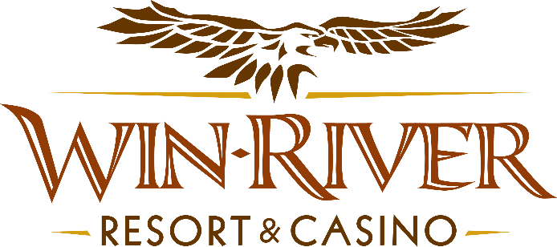

**2025 Table Games Blackjack Race**

**Official Rules**

* This Promotion will occur on Monday, March 3 & 17 from 1am – 2am.
* Top 10 winners with the most Blackjacks will receive cash or Free Play
* To participate in this promotion, guests must check in at the 21 Pit with their River Club Card and have a matching valid ID.
* Blackjack 21 Pit tables are eligible.
* All winners must sign a winner’s log.
* Must have a matching River Club Card and Valid ID.
  + A Valid ID includes the following: Guest Photo, Guest Name, Expiration Date, Issuing Government & Address. If the ID does not have an expiration date it is only valid up to 8 years after the issue date except Military ID.
  + If the guest does not have a Valid ID, then the prize will be forfeited.

**10 Winners**

**Prizes:**

**1st - $400 Cash**

**2nd - $350 Cash**

**3rd - $250 Cash**

**5th – 10th - $100 Free Play**

* **Promotions team is not needed for the Blackjack Races.**
* **Dealers and supervisors on shift should be able to track blackjacks and winners.**
* Win-River Resort & Casino team members are not eligible to participate in this promotion. The Marketing division's immediate family members are not eligible to participate in this promotion.
  + Spouse, domestic partner, parents, step-parents, siblings, step-siblings, children, step-children, grandparents, and grandchildren. This definition includes a team member’s eligible family member whether related by blood or adoption
* Win-River Resort & Casino reserves the right to change, modify or cancel this promotion at any time without prior notice.
* In accordance with the Internal Revenue Services, winners of prizes valued at $600 or above must provide their name, address and tax payer identification number (SSN) prior to receiving their prize. A 1099 Tax Form will be submitted

*Rules are subject to change. Must be a River Club Member to participate and have a valid ID. Must be 21 years or older to participate in any aspect of this promotion. Win-River Resort & Casino reserves the right to change or cancel this promotion at any time without prior notice.*