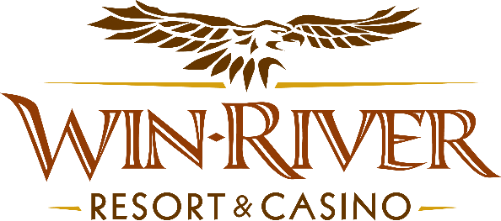

# **2025 Slot’s Cage Fight Hot Seats**

* This promotion will occur after event nights on the casino floor on April 12 from 9 pm to 11 pm.

# **Drawing Dates:**

**April 12**

# Two (2) hot seat winners every half-hour drawn to play our Mini Plinko Game to win up to $100 FSP.

* Each winner will get to play our Mini Plinko Game to win Free Slot Play.
  + - In the event of an error, (for example if the puck is stuck or dropped the orange Plinko puck, it will be unlogged and given back for the guest to try again.

**Prize Amounts:**

* **Prizes**
* **$50 FSP**
* **$75 FSP**
* **$100 FSP**

Guests must be playing with a River Club Card & have a Valid matching ID to participate.

* + A Valid ID includes the following: Guest Photo, Guest Name, Expiration Date, Issuing Government & Address. If the ID does not have an expiration date it is only valid up to 8 years after the issue date except Military ID.
  + If the guest does not have a Valid ID, the prize will be forfeited and the Promotions Team Member will draw for a new winner.
* A Promotions Team Member will pick 2 hot seat winners every half hour during this Promotion.
* Winners must sign the winner’s log.
* Free Slot Play can only be redeemed on Slot Machines and is non-transferable.
* All Free Slot Play $100 and over expires one week from the date & time issued.
* All Free Slot Play under $100 expires before 11:59 pm the following day.
* See River Club for instructions on using Free Slot Play on slot machines.
* Win-River Resort & Casino team members are not eligible to participate in this promotion. The Marketing division's immediate family members are not eligible to participate in this promotion.
* As defined in the WRRC Team Member Handbook Section 6.4 “immediate family member” includes the following:
  + Spouse, domestic partner, parents, step-parents, siblings, step-siblings, children, step-children, grandparents, and grandchildren. This definition includes a team member’s eligible family member whether related by blood or adoption.
* Win-River Resort & Casino and our designee(s) may use the names and likenesses of the Promotion winner(s) for promotional purposes without further compensation to Win-River Resort & Casino or the Promotion winner(s).
* By the Internal Revenue Service, winners of prizes valued at $600 or above must provide their name, address, and taxpayer identification number (SSN) before receiving their prize. A 1099 Tax Form will be submitted.

*Rules are subject to change. Must have a River Club Card and a valid ID. You must be 21 years or older to participate in any aspect of this promotion. Win-River Resort & Casino reserves the right to change, modify, or cancel this promotion at any time without prior notice.*