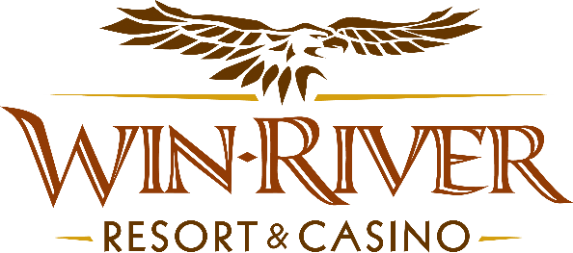

# **2025 Poker Room Anniversary Spring Splash pots**

# **Official Rules**

* This promotion will take place on Friday, May 9 & 23 from 8pm- 11pm **Prize Amounts**

**$100 Chips**

* ***Every hour, there will be a $100 Splash Pot on all live tables***
* *Guests must check into a live game with their River Club Card and have a matching valid ID to participate.*
* *Guests must have a matching River Club Card and valid ID to participate.*
  + *A Valid ID includes the following: Guest Photo, Guest Name, Expiration Date, Issuing Government & Address. If the ID does not have an expiration date it is only valid up to 8 years after the issue date with the exception of Military ID.*
* *If the guest does not have a Valid ID, then the prize will be forfeited.*
* *If more than one player wins the Splash pot, the $100 will be divided evenly between the players.*
* ***Winners must sign the winner’s log.***
* Win-River Resort & Casino team members are not eligible to participate in this promotion. The Marketing divisions immediate family members are not eligible to participate in this promotion.
* As defined in this WRRC Team Member Handbook Section 6.4 “immediate family member” includes the following.
  + Spouse, domestic partner, parents, step-parents, siblings, step-siblings, children, step-children, grandparents, and grandchildren. This definition includes a team member’s eligible family member whether related by blood or adoption.
* Win-River Resort & Casino and our designee(s) may use names and likenesses of Promotion winner(s) for promotional purposes without further compensation to Win-River Resort & Casino or the Promotion winner(s).
* In accordance with the Internal Revenue Services, winners of prizes valued at $600 or above must provide their name, address and tax payer identification number (SSN) prior to receiving their prize. A 1099 Tax Form will be submitted.

*Rules are subject to change. Must have a River Club Card and valid ID. Must be 21 years or older to participate in any aspect of this promotion. Win-River Resort & Casino reserves the right to change, modify or cancel this promotion at any time without prior notice.*