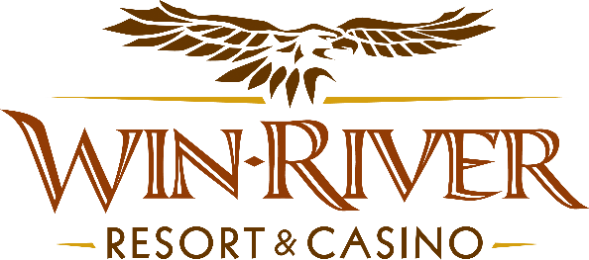

# **2025 Poker Room Caged Cash**

# **Official Rules**

* This promotion will take place Friday, April 11th from 11 pm to 12 am
* Any guests in the Poker Room playing any Live Poker Table will receive a raffle ticket to win Cash or (2) Tickets for the Cage Fights that will take place the following night on April 12th, 2025.
* Guests must have a matching River Club Card & Valid ID to participate.
  + A Valid ID includes the following: Guest Photo, Guest Name, Expiration Date, Issuing Government & Address. If the ID does not have an expiration date it is only valid up to 8 years after the issue date with the exception of Military ID.
  + If the guest does not have a Valid ID, then the prize will be forfeited.
* ***Winners must sign the winner’s log.***
* **Players must be actively playing a Poker Table to receive a Raffle Ticket**
* **Winners must be present to win**
* **Winners receive prizes based on their Raffle Ticket Number and time.**
* **Guests will win cash or (2) Tickets to the Cage Fights**

**Prize Amounts**

**(2)** **$100 Cash**

**(2) $150 Cash**

**(1) – Two Cage Fight Tickets – (GA-$55.00 + Fees)**

* Win-River Resort & Casino team members are not eligible to participate in this promotion. The Marketing divisions immediate family members are not eligible to participate in this promotion.
* As defined in this WRRC Team Member Handbook Section 6.4 “immediate family member” includes the following.
  + Spouse, domestic partner, parents, step-parents, siblings, step-siblings, children, step-children, grandparents, and grandchildren. This definition includes a team member’s eligible family member whether related by blood or adoption.
* Win-River Resort & Casino and our designee(s) may use names and likenesses of Promotion winner(s) for promotional purposes without further compensation to Win-River Resort & Casino or the Promotion winner(s).
* In accordance with the Internal Revenue Services, winners of prizes valued at **$600** or above must provide their name, address and tax payer identification number **(SSN)** prior to receiving their prize. A **1099 Tax Form** will be submitted.
* Foreign winners who win **$600** or more must pay 30% in taxes upon winning **(see SOP CD021)** otherwise their prize is forfeited and a new winner will be chosen.

*Rules are subject to change. Must have a River Club Card and valid ID. Must be 21 years or older to participate in any aspect of this promotion. Win-River Resort & Casino reserves the right to change, modify or cancel this promotion at any time without prior notice.*