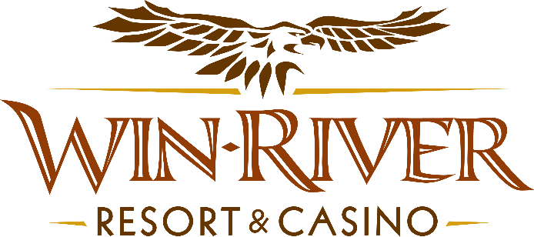

**2025 Table Games Anniversary Blackjack Race**

**Official Rules**

* This Promotion will occur on Monday, May 12, 2025 from 7pm – 9pm
* Top 10 winners with the most Blackjacks will receive cash or Free Play
* To participate in this promotion, guests must check in at the 21 Pit with their River Club Card and have a matching valid ID.
* Blackjack 21 Pit tables are eligible.
* All winners must sign a winner’s log.
* Must have a matching River Club Card and Valid ID.
  + A Valid ID includes the following: Guest Photo, Guest Name, Expiration Date, Issuing Government & Address. If the ID does not have an expiration date it is only valid up to 8 years after the issue date except Military ID.
  + If the guest does not have a Valid ID, then the prize will be forfeited.
* When there are ties in the game, the guest who initially gets their name put on first for blackjacks would be considered the lead.
* If a player leaves the table and is not playing, they are considered out of the race unless they rejoin and play until the end. Otherwise, proceed to the next player when choosing winners.
  + Guests must stay until the end of the promotion to find out if they are in the top 10.
  + If a top 10 winner is no longer in the casino when winners are announced and paid out, they will forfeit their prize and the next player with the most blackjacks will get the prize.
* To receive the Free Slot Play guests must be checked in at a live table with their River Club Card.
  + All Free Slot Play $100 and over expires one week from the date & time issued.
  + All Free Slot Play under $100 expires before 11:50 pm the following day.
* See River Club for instructions on using Free Slot Play on slot machines.

**10 Winners**

Prizes:

1st - $599 cash

2nd - $400 cash

3rd - $300 cash

4th - $200 cash

5th – 10th will receive $100 Free Slot Play

* Win-River Resort & Casino team members are not eligible to participate in this promotion. The Marketing division's immediate family members are not eligible to participate in this promotion.
  + Spouse, domestic partner, parents, step-parents, siblings, step-siblings, children, step-children, grandparents, and grandchildren. This definition includes a team member’s eligible family member whether related by blood or adoption
* Win-River Resort & Casino reserves the right to change, modify or cancel this promotion at any time without prior notice.
* In accordance with the Internal Revenue Services, winners of prizes valued at $600 or above must provide their name, address and tax payer identification number (SSN) prior to receiving their prize. A 1099 Tax Form will be submitted

*Rules are subject to change. Must be a River Club Member to participate and have a valid ID. Must be 21 years or older to participate in any aspect of this promotion. Win-River Resort & Casino reserves the right to change or cancel this promotion at any time without prior notice.*