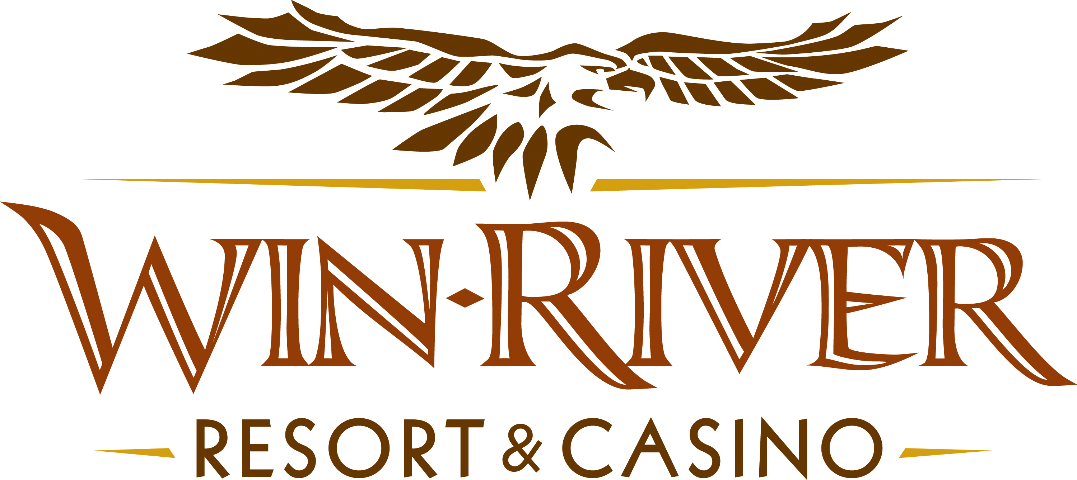

2025 $300,000 Anniversary S2W Drawing
Official Rules
May 1 – May 29, 2025

Weekly Drawings Thursdays from 7pm – 9pm
May 1, 8, 15, 22, 29
7pm:
- 2 winners are virtually drawn to spin the Super Prize Wheel
7:30pm:
- 2 winners are virtually drawn to spin the Super Prize Wheel
8pm:
- 2 winners are virtually drawn to spin the Super Prize Wheel
8:30pm:
- 2 winners are virtually drawn to spin the Super Prize Wheel
9pm:
- 2 winners are virtually drawn to spin the Super Prize Wheel

Weekly Drawings
- A Promotions Team Member will call names over PA/intercom.
- Guests can have their names called twice during weekly drawings.
- Guests have five (5) minutes to claim their prize; if not claimed within five (5) minutes, a Marketing Team Member will draw another name until all winners have claimed.
- Winners must have a matching Valid ID and River Club Card to participate and claim a prize.
  - A Valid ID includes the following: Guest Photo, Guest Name, Expiration Date, Issuing Government & Address. If the ID does not have an expiration date it is only valid up to 8 years after the issue date with the exception of Military ID.
  - If the guest does not have a valid ID, then the prize will be forfeited and the Promotions Team Member will draw for a new winner.
- Winners must sign the winner’s log.
- Winners are responsible for all taxes, licenses, and fees.
- Foreign winners must pay taxes upon winning otherwise their prize is forfeited and a new winner will be chosen.
Entries
- Win-River Resort & Casino carded guests may swipe their free River Club Card daily at any Promotional Kiosks located throughout the gaming floor. Instant Prizes will vary.
- Any carded guest who earns 200 points in a 24-hour promotional period will receive an extra entry into that weekly drawing.
- Earn 200 points and receive 4X’s entries on Sundays & Mondays
- Check-in and activate entries by; checking in at any Promotional Kiosk or by visiting the Promotions Stage.
- Guests can check-in between 6 pm and 9 pm on drawing nights
  - Once checked into the drawing, guests will be checked into all S2W drawings for that night.

Instant Prizes
- All Free Slot Play will expire at 11:50 pm on its issuance day.
  - Coupons can only be used by the person named on the receipt.
The Earning Period will be as follows:
- May 1 - May 29
- Guests have 5 minutes to claim a prize.
- All Winners must have a River Club Card and Valid ID to claim a prize.
- If a guest cannot present a valid ID in the 5 minutes, the guest will forfeit the prize.
- Winners must sign the winner’s log.
- The winner is responsible for all taxes, licenses, and fees.
- Win-River Resort & Casino team members are not eligible to participate in this promotion. The Marketing team member’s immediate family members are not eligible to participate in this promotion.
- As defined in the WRRC Team Member Handbook Section 6.4 “immediate family member” includes the following:
  - Spouse, domestic partner, parents, stepparents, siblings, stepsiblings, children, stepchildren, grandparents, and grandchildren. This definition includes a team member’s eligible family member whether related by blood or adoption
- Accounting is responsible for auditing, verifying, and recording both the revenue and expense side of the transaction.
- Win-River Resort & Casino and our designee(s) may use the names and likenesses of the Promotion winner(s) for promotional purposes without further compensation to Win-River Resort & Casino or the Promotion winner(s).
- In accordance with the Internal Revenue Services, winners of prizes valued at $600 or above must provide their name, address and taxpayer identification number (SSN) before receiving their prize. A 1099 Tax Form will be submitted.
- Winner must sign a Prize Voucher form, and winner’s log.
  - If winner does not have a social security card with them, a W-9 must be filled out and signed.

Rules are subject to change. Must have a valid ID. Must be 21 years or older to participate in any aspect of this promotion. Win-River Resort & Casino reserves the right to change or cancel this promotion at any time without prior notice.

APPROVED: |  |  | Approval Date:
RRTGA Executive Gaming Director

