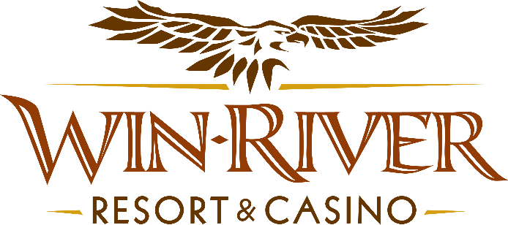

**2025 Table Games Summer Time Drawings**

**Official Rules**

* This Promotion will occur on on Monday, June 9, 16, 23, 30, & July 7, 14, 21, 28, 2025, from 3pm – 6pm
* Every half hour, from 3 PM to 6 PM, two hot seat winners will be drawn to win cash or free play chips.
* To participate in this promotion, guests must check in at the 21 Pit with their River Club Card and have a matching valid ID.
* **All 21 Pit tables are eligible.**
* All winners must sign a winner’s log.
* Must have a matching River Club Card and Valid ID.
  + A Valid ID includes the following: Guest Photo, Guest Name, Expiration Date, Issuing Government & Address. If the ID does not have an expiration date it is only valid up to 8 years after the issue date except Military ID.
  + If the guest does not have a Valid ID, then the prize will be forfeited.

**14 Winners**

**Prizes:**

**Cash Prize Amounts: $50, $75, $100**

**Free Play Amounts: $75**

* **Free Play Chips must be played before 11:59pm**
* **Free Play Chips cannot be played on the Roulette Table or CRAPS table**
* Win-River Resort & Casino team members are not eligible to participate in this promotion. The Marketing division's immediate family members are not eligible to participate in this promotion.
  + Spouse, domestic partner, parents, step-parents, siblings, step-siblings, children, step-children, grandparents, and grandchildren. This definition includes a team member’s eligible family member whether related by blood or adoption
* Win-River Resort & Casino reserves the right to change, modify or cancel this promotion at any time without prior notice.
* In accordance with the Internal Revenue Services, winners of prizes valued at $600 or above must provide their name, address and tax payer identification number (SSN) prior to receiving their prize. A 1099 Tax Form will be submitted
* Foreign winners who win $600 or more must pay 30% in taxes upon winning (see SOP CD021) otherwise their prize is forfeited and a new winner will be chosen.

*Rules are subject to change. Must be a River Club Member to participate and have a valid ID. Must be 21 years or older to participate in any aspect of this promotion. Win-River Resort & Casino reserves the right to change or cancel this promotion at any time without prior notice.*