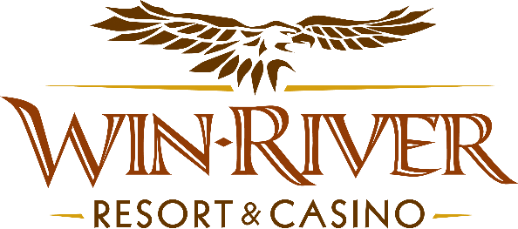

# **2025 Bingo Door Prize Drawing**

# **Official Rules**

# **Revised 2.11.25**

* This promotion will take place in the Event Center on Sunday, May 4, June 1, July 6, and August 3.
* Guests buying into Bingo with their River Club Cards will receive a Red Raffle from a Bingo Team Member.
* The other half of the Red Raffle Ticket's matching numbers will be in the drawing drum.
* After or during Bingo Sessions, five Red Raffle tickets are drawn from the drawing drum and announced one at a time.

**Drawing Dates:**

**May 4, June 1, July 6, & August 3.**

**Prizes:**

**(5) $100 Cash Winners**

* **No Duplicate Winners.**
* Guests buying in with their River Club Cards will receive a Red Raffle from a Bingo Team Member. The other half of the Red Raffle Ticket with their matching numbers will be put into the drawing drum.
* After or during Bingo sessions, five Red Raffle Tickets will be drawn from the drawing drum.
* Guests have one minute to claim their prize with a valid ID and River Club Card before a redraw.
* Guests must have a matching Valid ID & River Club Card to claim prizes.
  + A Valid ID includes the following: Guest Photo, Guest Name, Expiration Date, and Issuing Government & Address. If the ID does not have an expiration date, it is only valid up to 8 years after the issue date, except for Military ID.
  + If the guest does not have a Valid ID, the prize will be forfeited, and a Marketing Team Member will draw for a new winner.
* The guest will present the winning red raffle ticket to a Bingo Team Member with their valid ID and matching River Club Card.
* The winner will open an envelope to reveal their prize insert to the Marketing Team Member.
* Marketing Team Members will write in their prize, ID Expiration, River Club Card Number & Level, Guest Name, & Time.
* Winners must sign the winner’s log.
* Marketing Team Member will pay out winners.
* **All Payouts will happen in the Event Center.**
* Win-River Resort & Casino team members are not eligible to participate in this promotion. The Marketing division's immediate family members do not qualify for this promotion.
* As defined in the WRRC Team Member Handbook Section 6.4, “immediate family member” includes the following:
  + Spouse, domestic partner, parents, step-parents, siblings, step-siblings, children, step-children, grandparents, and grandchildren. This definition includes a team member’s eligible family member, whether related by blood or adoption.
* Win-River Resort & Casino and our designee(s) may use the names and likenesses of the Promotion winner(s) for promotional purposes without further compensation to Win-River Resort & Casino or the Promotion winner(s).
* By the Internal Revenue Service, winners of prizes valued at $600 or above must provide their name, address, and taxpayer identification number (SSN) before receiving their prize. A 1099 Tax Form will be submitted.

*Rules are subject to change. Must have a River Club Card and a valid ID. You must be 21 years or older to participate in this promotion. Win-River Resort & Casino reserves the right to change, modify, or cancel this promotion at any time without prior notice.*