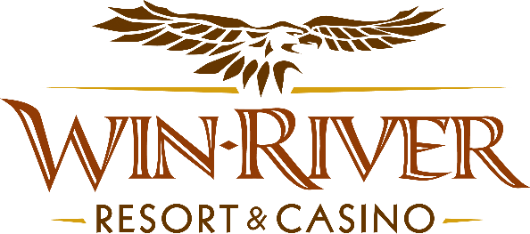

**2025 Monday Night Football T-shirt & Shot Glass Giveaway**

# **Official Rules**

This promotion will occur on **Mondays, September 8, through December 29, 2025**, from **4pm to 8pm**. Guest will earn **200 points** & swipe **their River Club Card** at any promotional Kiosk to print out coupon & give the coupon to one of our Promotion Specialist(s) to receive a **Monday Night Football Bundle.**

**Drawing Dates:**

**September 8, 15, 22, 29.**

**October 6, 13, 20, 27.**

**November 3, 10, 17, 24.**

**December 1, 8, 15, 22, 29.**

**Prizes:**

**Monday Night Football Bundle:**

* + One (1) Monday Night Football T-shirt.
  + One (1) 2oz Square Shot Glass.
* Guests can only receive **one (1) bundle** during the promotion event.
* **Sizes may vary.**
* **Available while supplies last**.
* The guest must redeem their **coupon** from the promotional kiosk **before 8:00 pm**.
* It is the **guest's responsibility** to take the coupon to a Promotion Specialist to receive their **MNF Bundle**.
* Coupon will expire at the **end of the promotion event** at **8:00 pm**.
* As defined in the WRRC Team Member Handbook Section 6.4, “immediate family member” includes the following:
  + Spouse, domestic partner, parents, step-parents, siblings, step-siblings, children, step-children, grandparents, and grandchildren. This definition includes a team member’s eligible family member, whether related by blood or adoption.
* Win-River Resort & Casino and our designee(s) may use the names and likenesses of the Promotion winner(s) for promotional purposes without further compensation to Win-River Resort & Casino or the Promotion winner(s).

*Rules are subject to change. Must have a River Club Card and a valid ID. Must be 21 years or older to participate in any aspect of this promotion. Win-River Resort & Casino reserves the right to change, modify or cancel this promotion at any time without prior notice.*