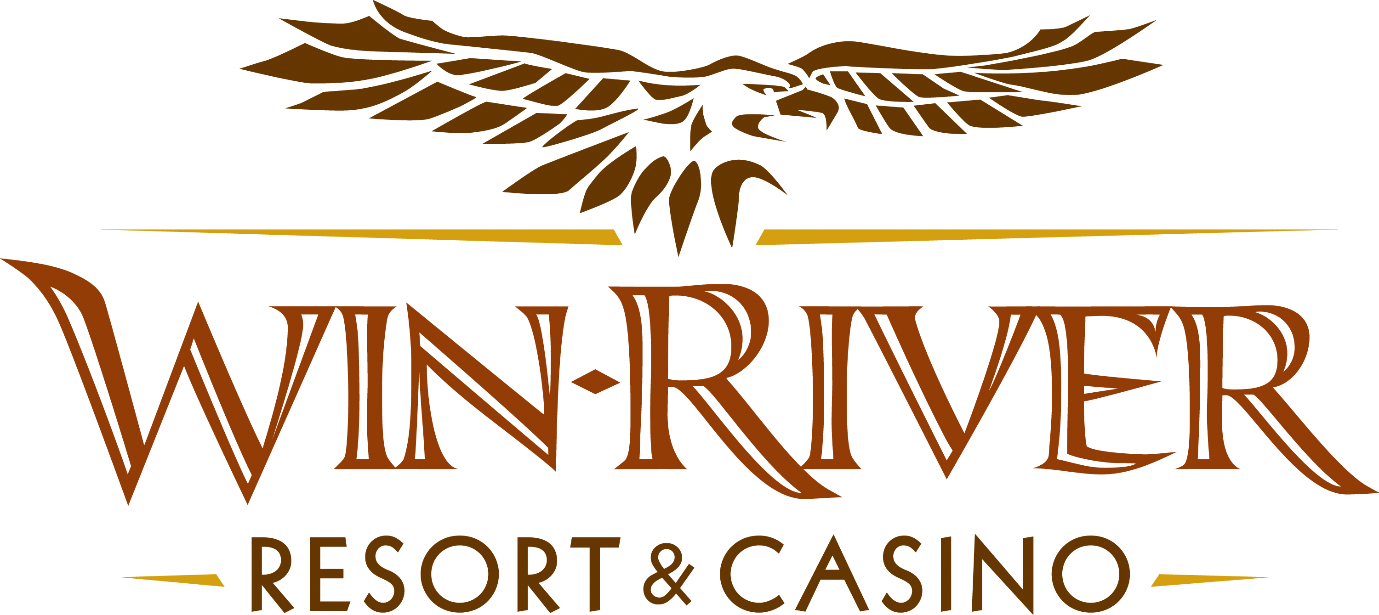

2025 $60,000 Wicked Winnings S2W Drawing
Official Rules
September 1 – October 30

This promotion will occur on Thursdays, September 1, throughout October 30, from 7 pm to 9 pm. A Marketing Team Member(s) will randomly draw five (5) winners to win up to $250 Free Slot Play and a choice of a baking set or BBQ set (BBQ and Bakery Sets are limited and will be given out while supplies last). Final Drawing will occur on October 30, from 7 pm to 9 pm. Five (5) winners will be randomly drawn to win up to $2,500 Cash Prize.

Weekly Drawings, September 4, 11, 18, 25:
7:00 pm – (5) $50 Free Slot Play and (5) BBQ Set
7:30 pm – (5) $100 Free Slot Play and (5) BBQ Set
8:00 pm – (5) $150 Free Slot Play and (5) BBQ Set
8:30 pm – (5) $200 Free Slot Play and (5) BBQ Set
9:00 pm – (5) $250 Free Slot Play and (5) BBQ Set
Weekly Drawings, October 2, 9, 16, 23:
7:00 pm – (5) $50 Free Slot Play and (5) Bakery Set
7:30 pm – (5) $100 Free Slot Play and (5) Bakery Set
8:00 pm – (5) $150 Free Slot Play and (5) Bakery Set
8:30 pm – (5) $200 Free Slot Play and (5) Bakery Set
9:00 pm – (5) $250 Free Slot Play and (5) Bakery Set
Final Drawings, October 30:
7:00 pm – (5) $500 Cash
7:30 pm – (5) $1,000 Cash
8:00 pm – (5) $1,500 Cash
8:30 pm – (5) $2,000 Cash
9:00 pm – (5) $2,500 Cash

Entries:
- Win-River Resort & Casino carded guests may swipe their free River Club Card daily at any of the Promotional kiosks located throughout the casino floor. With every swipe, a player will win virtual entries for weekly drawings on Thursdays from 7pm – 9pm.
  - One (1) Free Virtual Entry
  - Five (5) Free Virtual Entries
  - Ten (10) Free Virtual Entries
- The above list may be changed and/or modified per management.
- Any carded guest that earns 200 points in a 24-hour promotional period will receive an entry.
- Sundays & Mondays earn 200 points and receive 4X entries.
- Tuesdays, swipe at the promotional kiosks earn bonus entries from 10am to 6pm
  - Ten (10) Free Virtual Entries
  - Fifteen (15) Free Virtual Entries
  - Twenty (20) Free Virtual Entries
  - Twenty-five (25) Free Virtual Entries
- The above list may be changed and/or modified per management.
- All entries are inactive until guests check in by: Checking in at any Promotional Kiosk or by visiting the Promotions Stage.
- Guests can check-in between 6pm and 8:30 pm on drawing nights
  - Once checked into the drawing, guests will be checked into all S2W drawings for that night.
- All entries earned from September 1 – October 30 will be included in the October final drawing.
  - Drawing entries will expire after the final drawing on October 30.
- Guest be actively playing with their player card at any slot machine, table game, or poker table.
Disclaimers:
- Guests must be playing with a River Club Card & have a matching Valid ID to claim prizes.
  - A Valid ID includes the following: Guest Photo, Guest Name, Expiration Date, Issuing Government & Address. If the ID does not have an expiration date, it is only valid up to 8 years after the issue date, except for Military ID.
  - If the guest does not have a Valid ID, the prize will be forfeited, and the Marketing Team Member will draw for a new winner.
- Winners must sign the winner’s log.
- Win-River Resort & Casino team members are not eligible to participate in this promotion. The Marketing division's immediate family members are not eligible for this promotion.
- As defined in the WRRC Team Member Handbook Section 6.4, “immediate family member” includes the following:
  - Spouse, domestic partner, parents, step-parents, siblings, step-siblings, children, step-children, grandparents, and grandchildren. This definition includes a team member’s eligible family member, whether related by blood or adoption.
- Win-River Resort & Casino and our designee(s) may use the names and likenesses of the Promotion winner(s) for promotional purposes without further compensation to Win-River Resort & Casino or the Promotion winner(s).
- By the Internal Revenue Service, winners of prizes valued at $600 or above must provide their name, address, and taxpayer identification number (SSN) before receiving their prize. A 1099 Tax Form will be submitted.
- Foreign winners must pay 30% taxes upon winning otherwise, their prize is forfeited and a new winner will be chosen

Rules are subject to change. Must have a valid ID. Must be 21 years or older to participate in any aspect of this promotion. Win-River Resort & Casino reserves the right to change or cancel this promotion at any time without prior notice.

