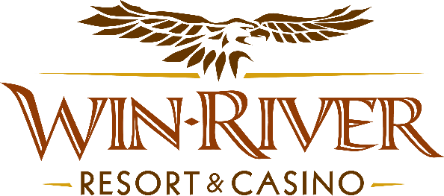

# **2025 Slot’s Sunflower Showers Hot Seat Drawing**

# **Official Rules**

* This hot seat drawing will be on the casino floor from 6 pm to 8 pm on September 2, 16, 23, & 30.

# Two (2) slots hot seat winners randomly drawn every half hour to pick a Sunflower to win Cash or Free Slot Play.

* **NO DUPLICATE WINNERS.**

* Guests must be actively playing any slot machine with a River Club Card to qualify & have a Valid ID to claim prizes.
  + A Valid ID includes the following: Guest Photo, Guest Name, Expiration Date, Issuing Government, & Address. If the ID does not have an expiration date, it is only valid for up to 8 years after the issue date, except for Military ID.
  + If the guest does not have a Valid ID, the prize will be forfeited, and the Promotions Team Member will draw for a new winner.
* Winners must sign the winner’s log.
* **All Cash payouts will be at the winner's slot machine.**
* Free Slot Play can only be redeemed on Slot Machines and is non-transferable.
* All Free Slot Play expires following the date issued before midnight.
* See River Club for instructions on using Free Slot Play on slot machines.
* Win-River Resort & Casino team members are not eligible to participate in this promotion. The Marketing division's immediate family members are not eligible to participate in this promotion.
* As defined in the WRRC Team Member Handbook Section 6.4, “immediate family member” includes the following:
  + Spouse, domestic partner, parents, step-parents, siblings, step-siblings, children, step-children, grandparents, and grandchildren. This definition includes a team member’s eligible family member, whether related by blood or adoption.
* Win-River Resort & Casino and our designee(s) may use the names and likenesses of the Promotion winner(s) for promotional purposes without further compensation to Win-River Resort & Casino or the Promotion winner(s).

*Rules are subject to change. Must have a River Club Card and a valid ID. You must be 21 years or older to participate in any aspect of this promotion. Win-River Resort & Casino reserves the right to change, modify, or cancel this promotion at any time without prior notice.*