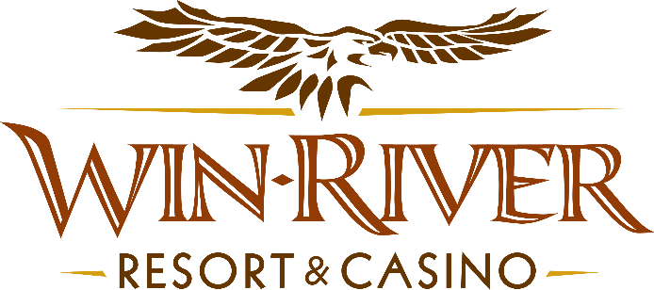

**2025 Table Games Summer Fortunes Party Pit**

**Official Rules**

This promotion will occur on **Monday, August 4 & 18, and Monday, September 8 & 22, 2025, from 3pm to 5pm.**

Every **half hour**, from **3pm until 5pm**, Marketing Team Member(s) will randomly draw **two Hot Seat winners**, (eight winner’s total) to spin the wheel and win up to $150 in cash, or up to $100 in Free Play Chips.

* Winners can choose a Poker Chip Case instead of spinning the wheel.

**Drawing Date:**

Monday, August 4 & 18, 2025

Monday, September 8 & 22, 2025

* The winner will **spin the prize wheel** and **can win up to $250 in Cash.**
* Winners will have **(1)** chance to spin and win Cash Prizes.
* If a winner **lands** on the **Free Space**, they have one more chance to spin the wheel.
* Once the Prize Wheel stops spinning, and stops on a prize, that will be the prize won.

**Prizes:**

* **Cash Prize Amounts**: $150
* **Free Play Chip Prize Amount**: $10, $20, $50, $75, $100

**Duplicate Winners are Expected, players can win twice.**

**All winners must sign a winner’s log.**

* + Guests must be 21 and over.
  + Guests check in at the 21 Pit with their River Club Card and have a matching valid ID.
* **Must have a matching River Club Card and Valid ID.**
  + A Valid ID includes the following: Guest Photo, Guest Name, Expiration Date, Issuing Government & Address. If the ID does not have an expiration date it is only valid up to 8 years after the issue date except Military ID.
  + If the guest does not have a Valid ID, then the prize will be forfeited.
* **All 21 Pit tables are eligible.**
* Free Play Chips **must be played before 11:59pm.**
* Free Play Chips **cannot be played** on the Roulette Table or CRAPS table.
* Free Play Chips can be played on **any other** Live Table Game.
* 21 Pit and Marketing will dress up and play music in the 21 Pit.
* Management has the right to change, cancel or modify promotion at any time. If determined to be in the best interest of the casino and its operations and in order to provide a premier gaming and entertainment experience for our guests, Division Directors and or Department Managers reserves the right to change, delete, or modify information within the Standard Operating Procedures **(SOP)** without advanced notice.
* Win-River Resort & Casino team members are not eligible to participate in this promotion. The Marketing team member’s immediate family members are not eligible to participate in this promotion.
* As defined in the WRRC Team Member Handbook Section 6.4 “immediate family member” includes the following.
* Spouse, domestic partner, parents, step-parents, siblings, step-siblings, children, step-children, grandparents, and grandchildren. This definition includes a team member’s eligible family member, whether related by blood or adoption
* Finance is responsible for auditing, verifying, and recording both the revenue and expense sides of the transaction.
* The operation must establish, as approved by the **TGRA**, the threshold level at which a variance must be reviewed to determine the cause. Any such review must be documented.
* If a variance occurs, see **SOP PE-6 Variances for Temporary Promotions**
* Rules can be downloaded by the River Club and Promotions Team Members from P:\2025 Rules.
* Rules may also be found by clicking the *Official Rules link* on WRRC website. www.winriver.com

*Rules are subject to change. Must be a River Club Member to participate and have a valid ID. Must be 21 years or older to participate in any aspect of this promotion. Win-River Resort & Casino reserves the right to change or cancel this promotion at any time without prior notice.*