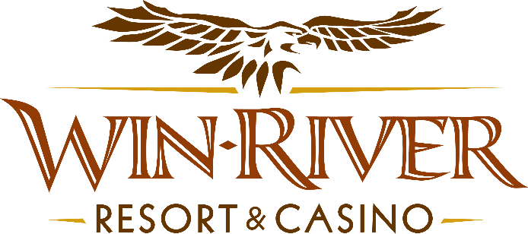

**Table Games Sleigh Ride & Vibes Party Pit**

**2025 Official Rules**

* This Promotion will occur on Monday, December 1, 2025, from 6pm to 9pm.
* Every hour, two hot seat winners will each pick a Gift Box and win up to $200 in Free Play, or up to $200 in Cash.
* To participate in this promotion, guests must check in at the 21 Pit with their River Club Card and have a matching valid ID.
* All 21 Pit tables are eligible.
* All winners must sign a winner’s log.
* Must have a matching River Club Card and Valid ID.
  + A Valid ID includes the following: Guest Photo, Guest Name, Expiration Date, Issuing Government & Address. If the ID does not have an expiration date it is only valid up to 8 years after the issue date except Military ID.
  + If the guest does not have a Valid ID, then the prize will be forfeited.
* Players who are wearing an Ugly Christmas Sweater at a Live Table Game can receive **$75 in Free Play Chips** from 6 pm to 9 pm
* **No duplicate winners in the same hour.**

**Prizes:**

2 x $100 Free Play Chips

2 x$50 Free Play Chips

2 x 200 Free Play Chip

2 x $100 Cash

1 x $200 Cash

|  |  |  |  |  |  |
| --- | --- | --- | --- | --- | --- |
|  |  |  |  |  |  |
|  | **How many winners** | **Cash** | **FP** |  |  |
| **6:00pm** | 2 | $200 | $200 |  |  |
| **7:00pm** | 2 | $200 | $200 |  |  |
| **8:00pm** | 2 | $200 | $200 |  |  |
| **9:00pm** | 2 | $200 | $200 |  |  |
|  |  | $800 | $800 |  |  |
|  | **Days** | 1 | 1 |  |  |
|  |  | $800 | $800 | $1,600 |  |
|  |  |  |  |  |  |
|  | **Budget** | $2,000 | $2,500 | $4,500 |  |
|  |  |  |  |  |  |
|  | **Variance** | **$1,200** | **$1,700** |  |  |
|  |  |  |  |  |  |

* Free Play Chips must be played before 11:59pm.
* Free Play Chips cannot be played on the Roulette Table or CRAPS table. Free Play Chips can be played on any other Live Table Game.
* **In the event of a computer malfunction, contact the IT Department for technical support.**
* **Contact the Director of Marketing for cancellation and/ or postponement of promotion.**
* Management has the right to change, cancel or modify promotion at any time. If determined to be in the best interest of the casino and its operations and in order to provide a premier gaming and entertainment experience for our guests, Division Directors and or Department Managers reserves the right to change, delete, or modify information within the Standard Operating Procedures **(SOP)** without advanced notice.
* Win-River Resort & Casino team members are not eligible to participate in this promotion. The Marketing team member’s immediate family members are not eligible to participate in this promotion.
* As defined in the WRRC Team Member Handbook Section 6.4 “immediate family member” includes the following.
* Spouse, domestic partner, parents, step-parents, siblings, step-siblings, children, step-children, grandparents, and grandchildren. This definition includes a team member’s eligible family member, whether related by blood or adoption
* Finance is responsible for auditing, verifying, and recording both the revenue and expense sides of the transaction.
* The operation must establish, as approved by the **TGRA**, the threshold level at which a variance must be reviewed to determine the cause. Any such review must be documented.
* If a variance occurs, see **SOP PE-6 Variances for Temporary Promotions**
* Rules can be downloaded by the River Club and Promotions Team Members from P:\2025 Rules.
* Rules may also be found by clicking the *Official Rules link* on WRRC website. www.winrivercasino.com

*Rules are subject to change. Must be a River Club Member to participate and have a valid ID. Must be 21 years or older to participate in any aspect of this promotion. Win-River Resort & Casino reserves the right to change or cancel this promotion at any time without prior notice.*