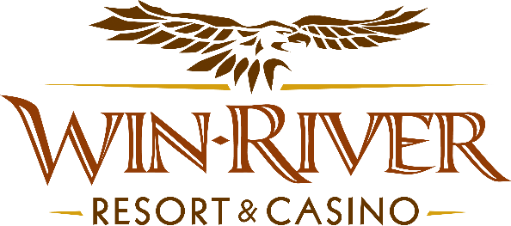

# **2025 Bingo Door Prize Drawing**

# **Official Rules**

This promotion will take place in the Event Center on first Sunday of the month, September 7, October 5, November 2 & December 7. Buy-ins start at 9 am, and Bingo starts at 12:00 pm. Guests buying into Bingo with their River Club Card will receive a Red Raffle from a Marketing Team Member. The other half of the Red Raffle Ticket's matching numbers will be in the drawing drum. After the Bingo Session, five random winners will be drawn to win $100 cash.

* **No Duplicate Winners.**
* Guests must have a matching Valid ID & River Club Card to claim prizes.
  + A Valid ID includes the following: Guest Photo, Guest Name, Expiration Date, and Issuing Government & Address. If the ID does not have an expiration date, it is only valid up to 8 years after the issue date, except for Military ID.
  + If the guest does not have a Valid ID and River Club Card, the prize will be forfeited, and a Marketing Team Member will draw for a new winner.
* Winners must sign the winner’s log.
* Win-River Resort & Casino team members are not eligible to participate in this promotion. The Marketing division's immediate family members do not qualify for this promotion.
* As defined in the WRRC Team Member Handbook Section 6.4, “immediate family member” includes the following:
  + Spouse, domestic partner, parents, step-parents, siblings, step-siblings, children, step-children, grandparents, and grandchildren. This definition includes a team member’s eligible family member, whether related by blood or adoption.
* Win-River Resort & Casino and our designee(s) may use the names and likenesses of the Promotion winner(s) for promotional purposes without further compensation to Win-River Resort & Casino or the Promotion winner(s).

*Rules are subject to change. Must have a River Club Card and a valid ID. You must be 21 years or older to participate in this promotion. Win-River Resort & Casino reserves the right to change, modify, or cancel this promotion at any time without prior notice.*