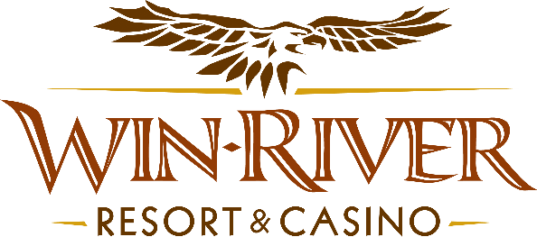

$33,000 New Year’s Eve Hot Seats Drawing

Official Rules

- This promotion will take place on Wednesday in December 31^{st,} 6 pm – 10 pm on the casino floor.
Drawing Dates:
December 31

Nine (9) hot seat winners will be drawn every half hour to win up $1,000 Cash.
- Twenty players from each Card Level will have a chance to win. (81) Eighty-One Winners in Total

  - 6pm Nine (9) players win up to $1000 Cash
  - 6:30pm Nine (9) players win up to $1000 Cash

  - 7pm Nine (9) players win up to $1000 Cash
  - 7:30pm Nine (9) players win up to $1000 Cash

  - 8pm Nine (9) players win up to $1000 Cash
  - 8:30pm Nine (9) players win up to $1000 Cash

  - 9pm Nine (9) players win up to $1000 Cash
  - 9:30pm Nine (9) players win up to $1000 Cash
  - 10pm Nine (9) players win up to $1000 Cash

- Guest can win more then once.
- Guests must be playing at any slot machine with a River Club Card & have a matching Valid ID to participate.
  - A Valid ID includes the following: Guest Photo, Guest Name, Expiration Date, an Issuing Government & Address. If the ID does not have an expiration date it is only valid up to 8 years after the issue date except for Military ID.
  - If the guest does not have a Valid ID, the prize will be forfeited and the Promotions Team Member will draw for a new winner.
- Winners must sign the winner’s log.
- All payouts will be done at the Slot Machine.
- Win-River Resort & Casino team members are not eligible to participate in this promotion. The Marketing division's immediate family members are not eligible to participate in this promotion.
- As defined in the WRRC Team Member Handbook Section 6.4 “immediate family member” includes the following:
  - Spouse, domestic partner, parents, step-parents, siblings, step-siblings, children, step-children, grandparents, and grandchildren. This definition includes a team member’s eligible family member whether related by blood or adoption.
- Win-River Resort & Casino and our designee(s) may use the names and likenesses of the Promotion winner(s) for promotional purposes without further compensation to Win-River Resort & Casino or the Promotion winner(s).
- By the Internal Revenue Service, winners of prizes valued at $600 or above must provide their name, address, and taxpayer identification number (SSN) before receiving their prize. A 1099 Tax Form will be submitted.
Rules are subject to change. Must have a River Club Card and a valid ID. You must be 21 years or older to participate in this promotion. Win-River Resort & Casino reserves the right to change, modify, or cancel this promotion at any time without prior notice.

APPROVED: |  |  | Approval Date:
RRTGA Executive Gaming Director

